Java Full Stack and React
Spring Boot simplifies backend development by proving auto-configurations, embedded servers and production ready features.
Auto-configurations - Before Spring boot developers had to configure XML files, front controllers, project build tool and Servers to develop web applications and Apis, but spring boot provides a ready to run application.
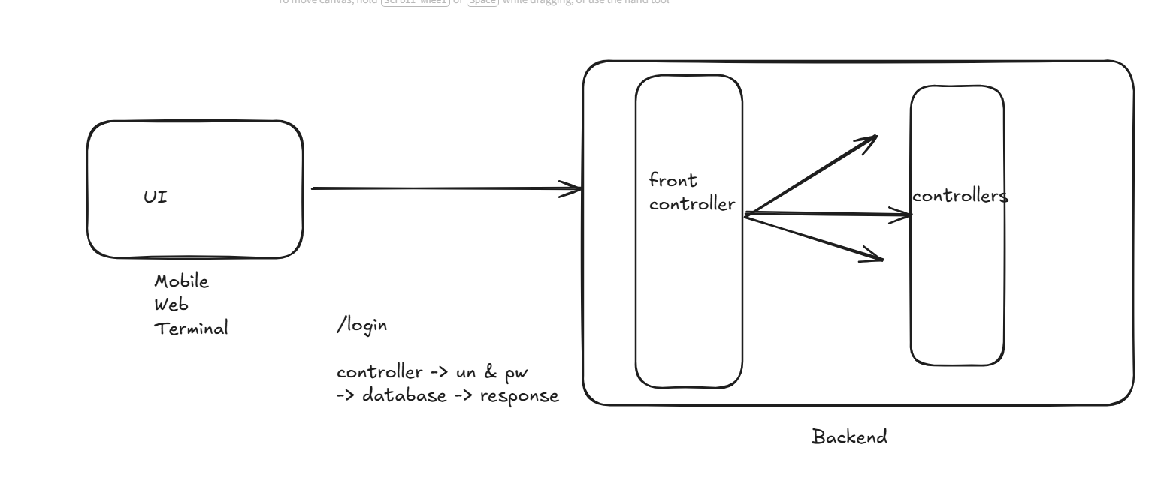

How to create REST API’s in Spring Boot
REST - Representational State Transfer
Two things used in REST API are
- URL
- HTTP methods - get, post, put & delete
@RestController
@RequestMapping(“/v1”)
public class AppController {
@GetMapping
public String test() { return “hello spring” }
}
In Spring Boot we have various annotations to perform the job for REST api
- @RestController - to mark the class as, REST API class that will have methods to handle the request
- @RequestMapping - to specify the URL to access the REST services
- @GetMapping, @PostMapping, @PutMapping, @DeleteMapping - these are HTTP methods for Get, Post, Put, Delete
Dependency
These are the libraries that helps spring boot to develop various features
- Web -> spring boot starter web : This gives all the features a web application must have
- Jpa -> spring boot data jpa : This gives all the features to connect with the DB
- Actuator -> spring boot actuator: This gives all the features required to monitor the application in the production

RestApi.java
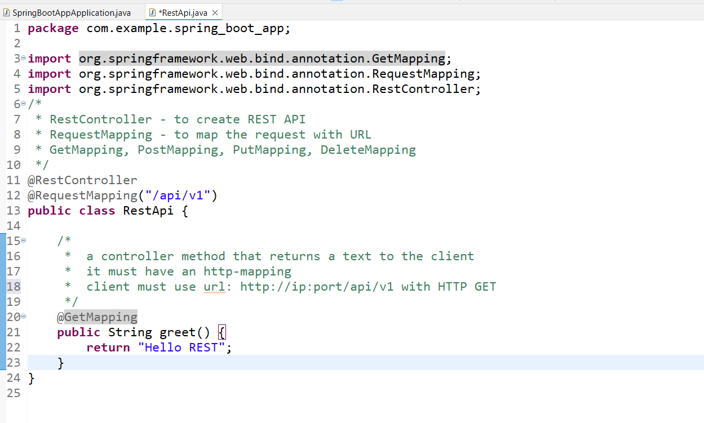
Output:

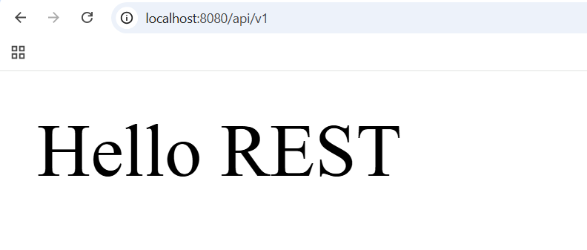
Add dependency devtools
